CS 255 Project 2 System Design Document

UML Diagrams

UML Use Case Diagram

[In Module Six, you were asked to complete a use case diagram based on your system design. If you would like to make any adjustments to your diagram, please do so. Please insert your use case diagram here. Check to make sure that you included appropriate components and symbols and that your design meets the client’s needs.]

The use case diagram below shows the main users of the DriverPass system and what each of them can do. I updated my Module Six diagram for this project. Customers can pick a package, take online classes and practice tests, check their test progress, reset a forgotten password, and contact DriverPass. Both customers and the secretary can register or update customer information and schedule, modify, or cancel lessons, since the secretary handles customers who call or visit the office. Drivers can view their driving schedule and record lesson notes, Ian manages user accounts (reset or block), and Liam can view and download reports, print the activity report, disable packages, and receive DMV updates. The DMV is shown as an outside system that sends those updates.
One change from my Module Six diagram is that I took out the Log In use case. Logging in is not really a goal a user has. It is something they do before every task, so I treated it as a requirement for all the use cases instead of drawing it as its own oval. This also removed a lot of crossing lines and made the diagram much easier to read. Logging in is still shown in the activity and sequence diagrams below.

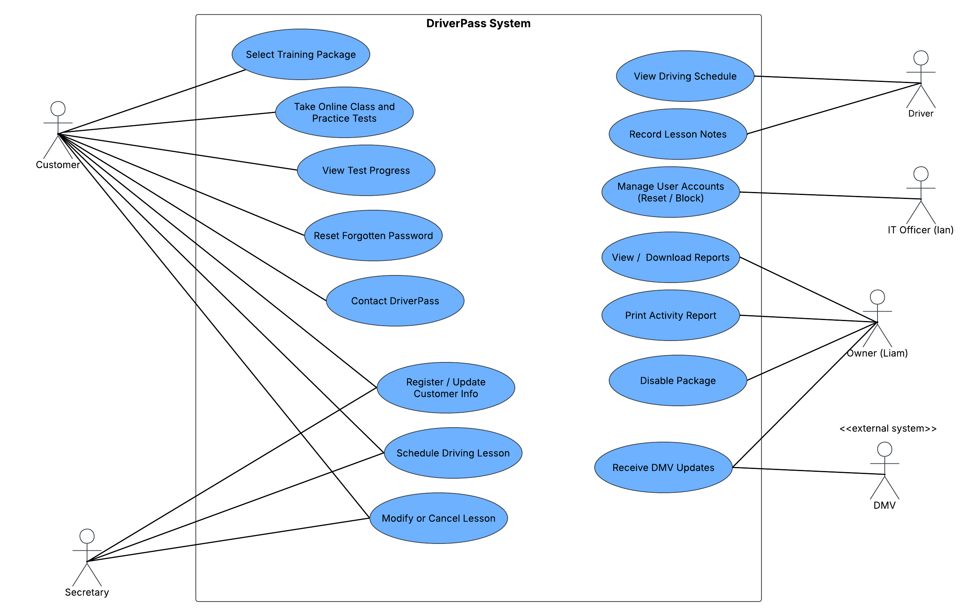

Figure 1. DriverPass use case diagram

UML Activity Diagrams
[You were asked to choose two use cases and create two activity diagrams, one for each use case. Please insert both of your activity diagrams here. Check to make sure that you included appropriate components and symbols and that your design meets the client’s needs.]

I picked two use cases that are important to how DriverPass makes money and serves its customers: scheduling a driving lesson and registering a new customer. Both diagrams use swimlanes so it is clear what the user does and what the system does.

Activity Diagram 1: Schedule Driving Lesson

This diagram shows a customer logging in and booking a two-hour lesson. The system checks that the package is still active and has hours left, then only shows open times. If the driver and car are already taken, the customer picks a different time. Once a slot works, the system assigns a driver and car, saves the reservation, and records who made it in the activity log, which covers Liam's request to know who made, changed, or canceled a reservation. I split the diagram into two parts (logging in and choosing to schedule, then picking up a time and confirming) so it fits on one page and is easier to read.

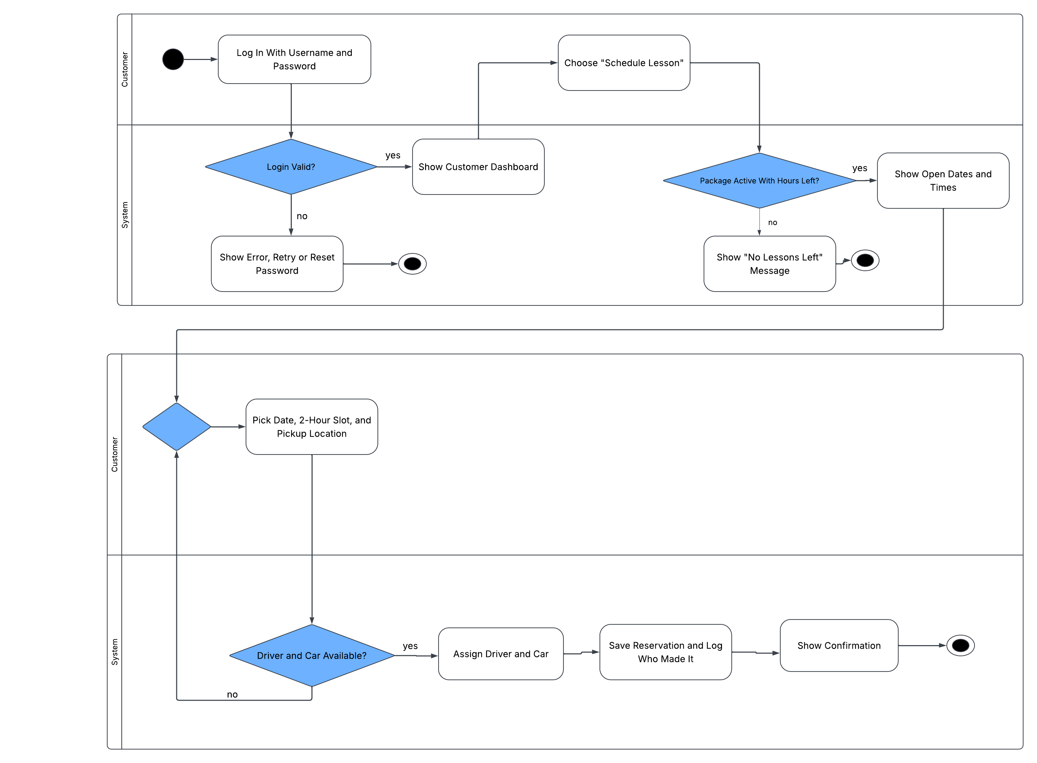

Figure 2. Activity diagram for scheduling a driving lesson

Activity Diagram 2: Register Customer and Select Package

This diagram covers registration, which can be done online by the customer or by the secretary over the phone. The customer's information is entered and checked, and only active packages are shown so a package Liam disabled can't be picked. After payment is approved, the account is created. If the customer chooses Package Three, they also get access to the online class and practice tests.
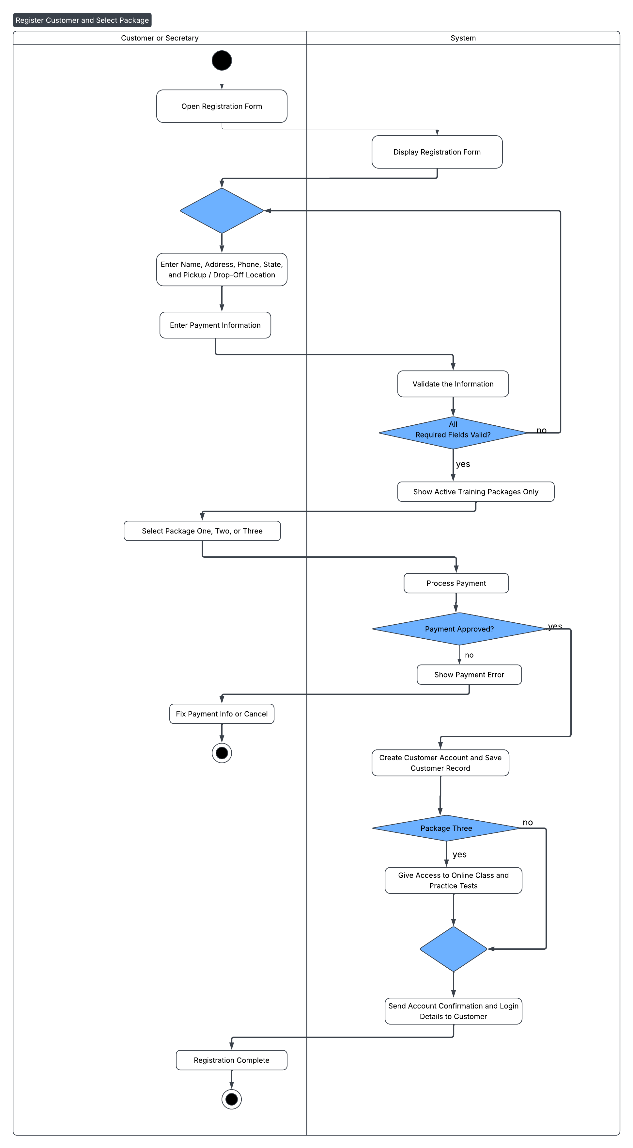
Figure 3. Activity diagram for registering a customer and selecting a package

UML Sequence Diagram
[You were asked to create a sequence diagram based on one of the use cases you chose. Please insert your sequence diagram here. Check to make sure that you included appropriate components and symbols and that your design meets the client’s needs.]

The sequence diagram is based on the Schedule Driving Lesson use case. It shows the order of messages between the customer, the web interface, the login and reservation controllers, and the database. Solid arrows are requests and dashed arrows are replies. I kept it to the main successful path, since the failed login case is already covered in the activity diagram. After the customer picks a time, the reservation controller checks one more time that the driver and car are still free (so two people can't book the same slot), saves the reservation, and saves an activity log entry.
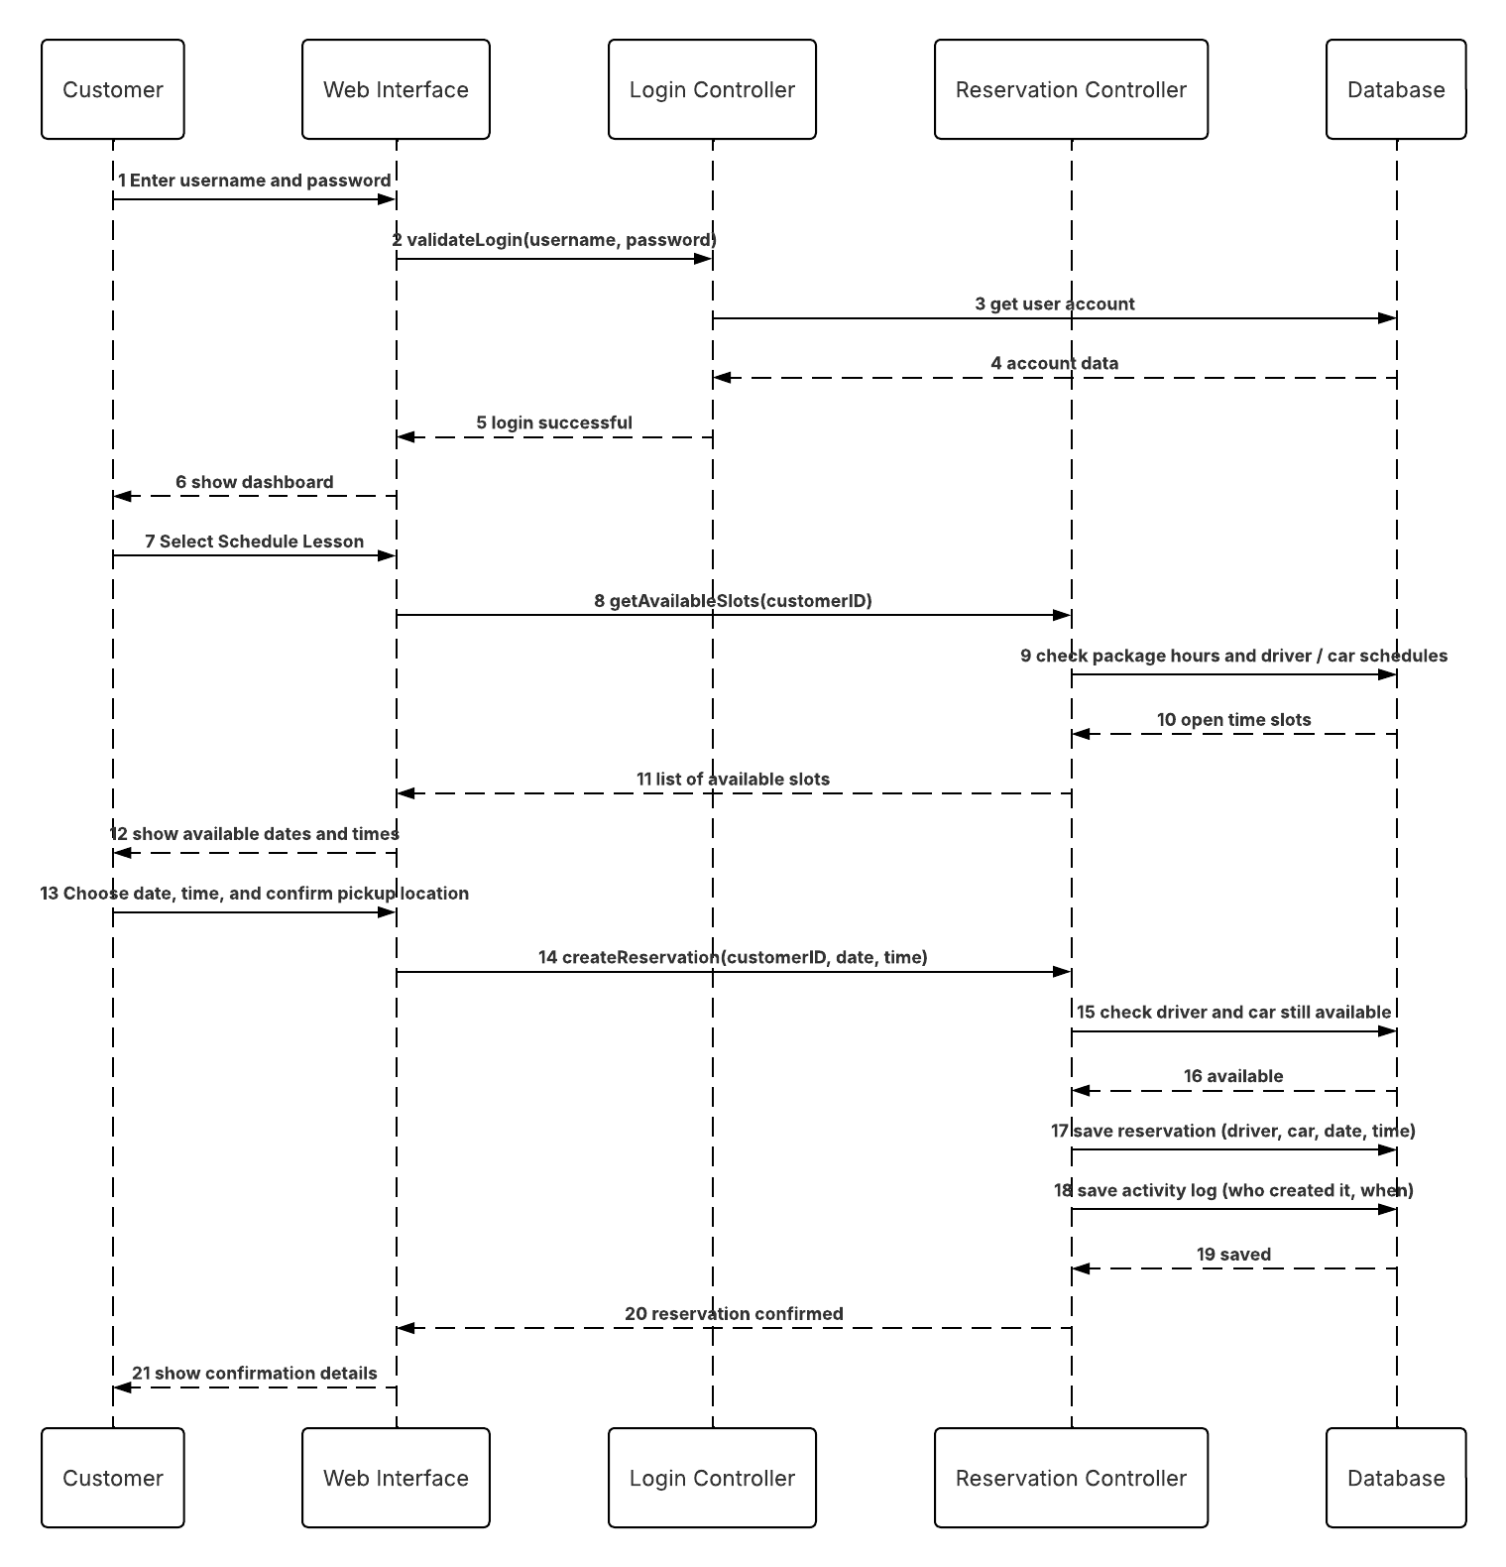
Figure 4. Sequence diagram for scheduling a driving lesson

UML Class Diagram
[You were asked to create a class diagram based on the different classes and attributes needed for your system design. You are not required to include methods, but you may if you wish. Please insert your class diagram here. Check to make sure that you included appropriate components and symbols and that your design meets the client’s requirements.]

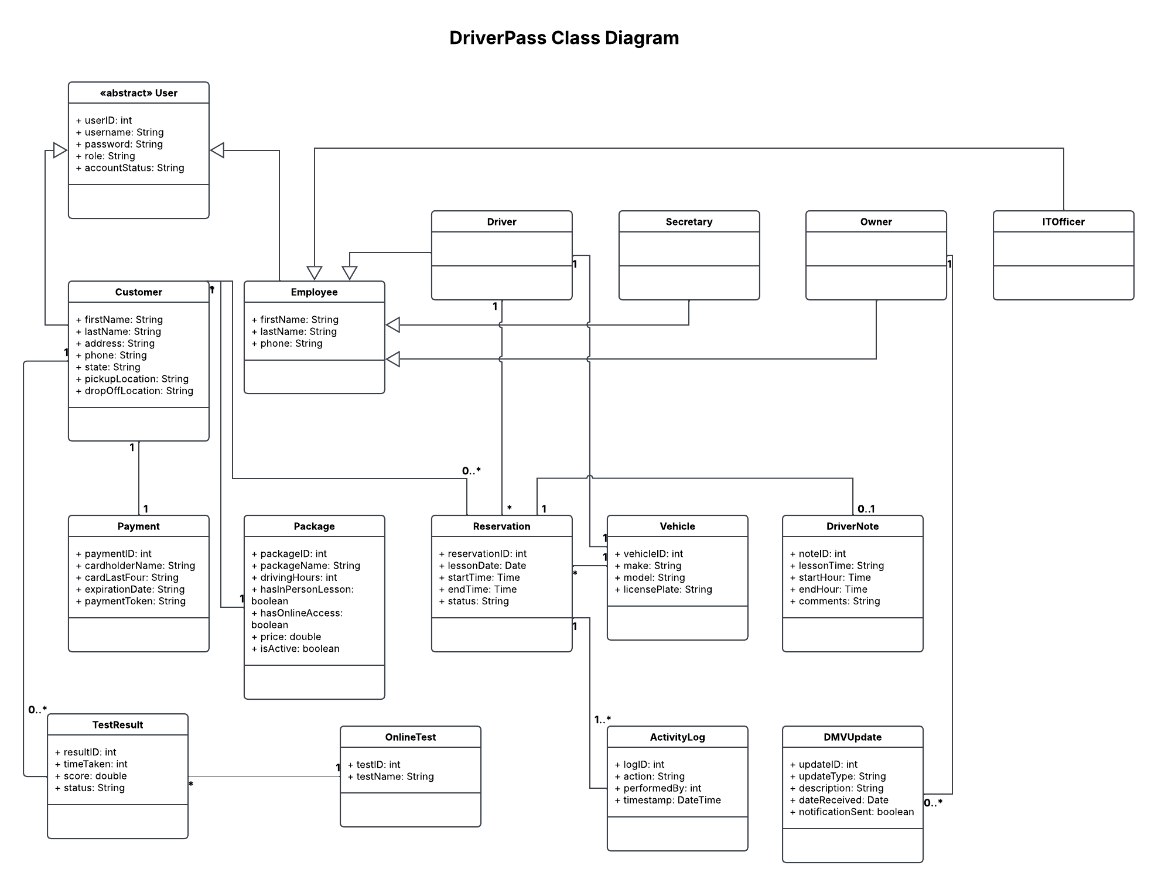
Figure 5. DriverPass class diagram

UML Class Diagram

The class diagram shows the main classes and attributes for the system. User is an abstract parent class with the login information, and Customer and Employee inherit from it. Driver, Secretary, Owner, and ITOfficer inherit from Employee, which makes role-based access easier. Reservation connects a customer with a driver, a vehicle, a date, and a time. TestResult and OnlineTest hold the test progress Liam wants to see, DriverNote holds the lesson times and driver comments, ActivityLog tracks changes to reservations, and DMVUpdate stores updates from the DMV. Package has an isActive attribute so Liam can disable a package. For Payment, I chose to store a token and the last four digits instead of the full card number and security code, since the actual card details should be handled by a payment processor.

Technical Requirements
[Based on the diagrams you have created, describe the technical requirements of your system. These requirements should address the required hardware, software, tools, and infrastructure necessary for your system design.]

Hardware
DriverPass won't need to buy its own servers because the system will be hosted by a cloud provider such as AWS. Customers and staff only need a computer, tablet, or phone with a web browser and an internet connection. Drivers will use a phone or tablet to see their schedule and add lesson notes, and the office will need a printer for the activity report.

Software

The system will be a website that works on both computers and phones, so nobody has to install an app. It will need a database, such as MySQL, to store everything shown in the class diagram, like customers, reservations, vehicles, test results, driver notes, and the activity log. Reports should be downloadable as Excel or PDF files so Liam can look at them offline. Credit card payments should go through an outside payment service so DriverPass doesn't have to keep full card numbers.

Tools

The team will use Lucidchart for the UML diagrams, a code editor such as Visual Studio Code to build the system, and GitHub to save and share the code. The system will be tested before it is delivered to DriverPass, following the project schedule.

Infrastructure

The cloud provider will handle hosting and automatic backups, and it can grow if DriverPass gets more customers. The website will use a secure connection (HTTPS) so personal and payment information is protected. Each user will have their own login, and they will only see what their role allows. Ian will be able to reset or block accounts, accounts will lock after too many wrong passwords, and customers can reset a forgotten password by email. The system will also connect to the DMV so new rules and sample questions come in automatically and Liam gets a notification. Since changes can only be made online, everyone works from the same up-to-date information.

